# Chapter 8 Lab More Classes and Objects

**Lab Objectives**

* Be able to write a copy constructor
* Be able to write equals and toString methods
* Be able to use objects made up of other objects (aggregation)
* Be able to write methods that pass and return objects

# Introduction

We discussed objects in Chapter 6, and we modeled a television in the Chapter 6 lab. We want build on that lab, and work more with objects. This time, the object that we are choosing is more complicated. It is made up of other objects. This is called aggregation. A credit card is an object that is very common, but not as simple as a television.

Attributes of the credit card include information about the owner, as well as a balance and credit limit. These things would be our instance fields. A credit card allows you to make payments and charges. These would be methods. As we have seen before, there would also be other methods associated with this object in order to construct the object and access its fields.

Examine the UML diagram that follows. Notice that the instance fields in the CreditCard class are other types of objects: a Person object and a Money object. We can say that the CreditCard object *“has a”* Person object, which means aggregation, and the Person object *“has a”* Address object as one of its instance fields. This aggregation structure can create a very complicated object. We will try to keep this lab reasonably simple.

To start with, we will be editing a partially written class, Money. The constructor that you will be writing is a copy constructor. This means it should create a new object, but with the same values in the instance variables as the object that is being copied.

Next, we will write the equals and toString methods. These are very common methods that are needed when you write a class to model an object. You will also see a compareTo method that is also a common method for objects.

After we have finished the Money class, we will write a CreditCard class. This class contains Money objects, so you will use the methods that you have written to complete the Money class. The CreditCard class will explore passing objects and the possible security problems associated with it. We will use the copy constructor we wrote for the Money class to create new objects with the same information to return to the user through the accessor methods.

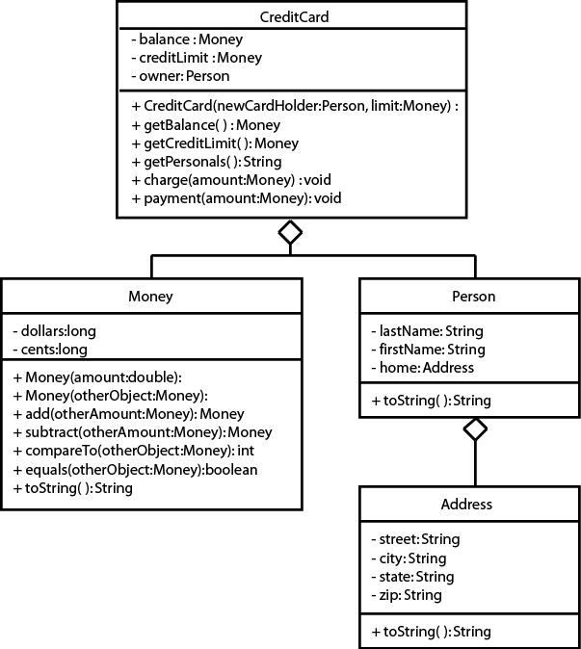

# Task #1 Writing a Copy Constructor

1. Copy the files *Address.java* (Code Listing 8.1), *Person.java* (Code Listing 8.2), *Money.java* (Code Listing 8.3), *MoneyDemo.java* (Code Listing 8.4), and *CreditCardDemo.java* (Code Listing 8.5) from the Student Files or as directed by your instructor. Address.java, Person.java, MoneyDemo.java, and CreditCardDemo.java are complete and will not need to be modified. We will start by modifying Money.java.
2. Overload the constructor. The constructor that you will write will be a copy

constructor. It should use the parameter Money object to make a duplicate Money object, by copying the value of each instance variable from the parameter object to the instance variable of the new object.

# Task #2 Writing the equals and toString methods

1. Write and document an equals method. The method compares the instance variables of the calling object with instance variables of the parameter object for equality and returns true if the dollars and the cents of the calling object are the same as the dollars and the cents of the parameter object. Otherwise, it returns false.
2. Write and document a toString method. This method will return a String that looks like currency, including the dollar sign. Remember that if you have less than 10 cents, you will need to put a 0 before printing the cents so that it appears correctly with 2 decimal places.
3. Compile, debug, and test by running the MoneyDemo program. You should get the following output:

The current amount is $500.00 Adding $10.02 gives $510.02 Subtracting $10.88 gives $499.14

$10.02 equals $10.02

$10.88 does not equal $10.02

# Task #3 Passing and Returning Objects

1. Create the CreditCard class according to the UML diagram. It should have data fields that include an owner of type Person, a balance of type Money, and a creditLimit of type Money.
2. It should have a constructor that has two parameters, a reference to a Person object to initialize the owner and a reference to a Money object to initialize the creditLimit. The balance can be initialized to a Money object with a value of zero. Remember you are passing in objects (passed by reference), so you are passing the memory address of an object. If you want your CreditCard to have its own creditLimit and balance, you should create a new object of each using the copy constructor in the Money class.
3. It should have accessor methods to get the balance and the creditLimit. Since these are Money objects (passed by reference), we don’t want to create a security issue by passing out addresses to components in our CreditCard class, so we must return a new object with the same values. Again, use the copy constructor to create a new object of type Money that can be returned.
4. It should have an accessor method to get the information about the owner, but in the form of a String that can be printed out. This can be done by calling the toString method for the owner (an instance of the Person class).
5. It should have a method that will charge to the CreditCard by adding the amount passed in the parameter to the balance, but only if it will not exceed the creditLimit. If the creditLimit will be exceeded, the amount should not be added, and an error message can be printed to the console.
6. It should have a method that will make a payment on the CreditCard by subtracting the amount passed in the parameter from the balance.
7. Compile, debug, and test it out completely by running the CreditCardDemo

program.

1. You should get the output:

Diane Christie, 237J Harvey Hall, Menomonie, WI 54751 Balance: $0.00

Credit Limit: $1000.00

Attempting to charge $200.00 Charge: $200.00

Balance: $200.00

Attempting to charge $10.02 Charge: $10.02

Balance: $210.02

Attempting to pay $25.00 Payment: $25.00

Balance: $185.02

Attempting to charge $990.00 Exceeds credit limit Balance: $185.02

# Code Listing 8.1 (Address.java)

/**

This class defines an address using a street, city, state, and zipcode.

*/

public class Address

{

// The street number and name private String street;

// The city in which the address is located private String city;

// The state in which the address is located private String state;

// The zip code associated with the city and street private String zip;

/**

Constructor

@param road Describes the street number and name. @param town Describes the city.

@param st Describes the state.

@param zipCode Describes the zip code.

*/

public Address(String road, String town, String st, String zipCode)

{

street = road; city = town; state = st; zip = zipCode;

}

/**

The toString method

@return Information about the address.

*/

public String toString()

{

return (street + ", " + city +

", " + state + " " + zip);

}

}

# Code Listing 8.2 (Person.java)

/**

This class defines a person by name and address.

*/

public class Person

{

// The person's last name private String lastName;

// The person's first name private String firstName;

// The person's address private Address home;

/**

Constructor

@param last The person's last name. @param first The person's first name. @param residence The person's address.

*/

public Person(String last, String first,

Address residence)

{

lastName = last; firstName = first; home = residence;

}

/**

The toString method

@return Information about the person.

*/

public String toString()

{

return(firstName + " " + lastName + ", " + home.toString());

}

}

# Code Listing 8.3 (Money.java)

/**

This class represents nonnegative amounts of money.

*/

public class Money

{

// The number of dollars private long dollars;

// The number of cents private long cents;

/**

Constructor

@param amount The amount in decimal format.

*/

public Money(double amount)

{

if (amount < 0)

{

System.out.println("Error: Negative amounts " +

"of money are not allowed.");

System.exit(0);

}

else

{

long allCents = Math.round(amount * 100); dollars = allCents / 100;

cents = allCents % 100;

}

}

// ADD LINES FOR TASK #1 HERE

// Document and write a copy constructor

/**

The add method

@param otherAmount The amount of money to add. @return The sum of the calling Money object

and the parameter Money object.

*/

public Money add(Money otherAmount)

{

Money sum = new Money(0);

sum.cents = this.cents + otherAmount.cents; long carryDollars = sum.cents / 100; sum.cents = sum.cents % 100;

sum.dollars = this.dollars +

otherAmount.dollars + carryDollars;

return sum;

}

/**

The subtract method

@param amount The amount of money to subtract. @return The difference between the calling Money

object and the parameter Money object.

*/

public Money subtract (Money amount)

{

Money difference = new Money(0);

if (this.cents < amount.cents)

{

this.dollars = this.dollars - 1; this.cents = this.cents + 100;

}

difference.dollars = this.dollars - amount.dollars; difference.cents = this.cents - amount.cents;

return difference;

}

/**

The compareTo method

@param amount The amount of money to compare against. @return -1 if the dollars and the cents of the

calling object are less than the dollars and the cents of the parameter object.

* 1. if the dollars and the cents of the calling object are equal to the dollars and cents of the parameter object.
  2. if the dollars and the cents of the calling object are more than the dollars and the cents of the parameter object.

*/

public int compareTo(Money amount)

{

int value;

if(this.dollars < amount.dollars) value = -1;

else if (this.dollars > amount.dollars) value = 1;

else if (this.cents < amount.cents) value = -1;

else if (this.cents > amount.cents) value = 1;

else

value = 0;

return value;

}

// ADD LINES FOR TASK #2 HERE

// Document and write an equals method

// Document and write a toString method

}

# Code Listing 8.4 (MoneyDemo.java)

/**

This program demonstrates the Money class.

*/

public class MoneyDemo

{

public static void main(String[] args)

{

// Named constants

final int BEGINNING = 500; // Beginning balance final Money FIRST_AMOUNT = new Money(10.02); final Money SECOND_AMOUNT = new Money(10.02); final Money THIRD_AMOUNT = new Money(10.88);

// Create an instance of the Money class with

// the beginning balance.

Money balance = new Money(BEGINNING);

// Display the current balance. System.out.println("The current amount is " +

balance.toString());

// Add the second amount to the balance

// and display the results.

balance = balance.add(SECOND_AMOUNT); System.out.println("Adding " + SECOND_AMOUNT +

" gives " + balance.toString());

// Subtract the third amount from the balance

// and display the results.

balance = balance.subtract(THIRD_AMOUNT); System.out.println("Subtracting " + THIRD_AMOUNT +

" gives " + balance.toString());

// Determine if the second amount equals

// the first amount and store the result.

boolean equal = SECOND_AMOUNT.equals(FIRST_AMOUNT);

// Display the result. if(equal)

{

// The first and second amounts are equal. System.out.println(SECOND_AMOUNT + " equals " +

FIRST_AMOUNT);

}

else

{

// The first and second amounts are not equal. System.out.println(SECOND_AMOUNT +

" does not equal " + FIRST_AMOUNT);

}

// Determine if the third amount equals

// the first amount and store the result. equal = THIRD_AMOUNT.equals(FIRST_AMOUNT);

// Display the result. if(equal)

{

// The third and first amounts are equal. System.out.println(THIRD_AMOUNT + " equals " +

FIRST_AMOUNT);

}

else

{

// The third and first amounts are not equal. System.out.println(THIRD_AMOUNT +

" does not equal " + FIRST_AMOUNT);

}

}

}

# Code Listing 8.5 (CreditCardDemo.java)

/**

This program demonstrates the CreditCard class.

*/

public class CreditCardDemo

{

public static void main(String[] args)

{

// Named constants

final Money CREDIT_LIMIT = new Money(1000); final Money FIRST_AMOUNT = new Money(200); final Money SECOND_AMOUNT = new Money(10.02); final Money THIRD_AMOUNT = new Money(25); final Money FOURTH_AMOUNT = new Money(990);

// Create an instance of the Person class. Person owner = new Person("Christie", "Diane",

new Address("237J Harvey Hall", "Menomonie", "WI", "54751"));

// Create an instance of the CreditCard class. CreditCard visa = new CreditCard(owner,

CREDIT_LIMIT);

// Display the credit card information. System.out.println(visa.getPersonals()); System.out.println("Balance: " + visa.getBalance()); System.out.println("Credit Limit: " +

visa.getCreditLimit()); System.out.println(); // To print a new line

// Attempt to charge the first amount and

// display the results. System.out.println("Attempting to charge " +

FIRST_AMOUNT);

visa.charge(FIRST_AMOUNT); System.out.println("Balance: " + visa.getBalance());

System.out.println(); // To print a new line

// Attempt to charge the second amount and

// display the results. System.out.println("Attempting to charge " +

SECOND_AMOUNT);

visa.charge(SECOND_AMOUNT); System.out.println("Balance: " + visa.getBalance());

System.out.println(); // To print a new line

// Attempt to pay using the third amount and

// display the results. System.out.println("Attempting to pay " +

THIRD_AMOUNT);

visa.payment(THIRD_AMOUNT); System.out.println("Balance: " + visa.getBalance());

System.out.println(); // To print a new line

// Attempt to charge using the fourth amount and

// display the results. System.out.println("Attempting to charge " +

FOURTH_AMOUNT);

visa.charge(FOURTH_AMOUNT); System.out.println("Balance: " + visa.getBalance());

}

}